MUSIC PLAYGROUND OVERVIEW

Create your audio collection in html in 2 steps !

I can call it "html music player". Tracklist, Mix List, Album Panel, Cover Panel & Cover List are parts of
page with amazing dynamic preview made by milka (amilino@gmail.com).

Installation:
Click on 'Start' in the taskbar and run the Execute/Run-command. Type the following in the box:
%appdata%/Mp3tag/export
An explorer window will open and there you can copy the export scripts to.

Important:
Do not use symbol ‘ (apostrophe) in album path or cover name and # (number sign) at the beginning of
folder or cover name, because auto-sizing image popup window link won’t work.
You can replace ‘ with ` and # with %.

Recommended:
Place image cover.jpg and text file Review.txt in each album folder. Or you can open the export script
or the output file and look in the script area the following line:
// ++++++++++++++++++ DEFINE THE NAMES ++++++++++++++++++ //
Below this line there is a brief description and you can define the names of the covers and the reviews
you wont to use. So when you don’t wont to call your covers in the directories "cover.jpg", simply edit
the specific line.

Tags:
%genre%

This field is user-defined field for ID3v2.x and ID3v1. So it is sub-tag of the "User defined text
information frame" (TXXX). All user-defined tags are stored there. Like every other user-defined field
they are created for special reasons. They help to catalog the music much better.

Writing tags:

User-defined fields are easy to access. In Mp3tag you click on a song, press the keys [ALT]+[T] and
then on "Adding new tag-field" On the list, where you can choose a field, you can type for example
GENRE and then you can type genre in the value in the field below.

Usage (example directory: C:\Music):

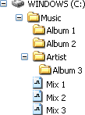

- Step (Album Playlist):
- Change directory… [Ctrl]+[D] --> Music
- Export [Ctrl]+[E] --> milkaPlayground 01 m3u Album Playlist.mte (activate 'One file per directory')

- Step (Album & Mix List):
- Export [Ctrl]+[E] --> milkaPlayground 02 html Album & Mix List.mte (uncheck ‘One file per directory’)
- Export [Ctrl]+[E] --> milkaPlayground 03 bat Music Playground Files Extractor.mte (leave ‘One file
per directory' unchecked) --> After exporting when you are asked to display exported file now click Yes to run batch file that will extract images that are needed for page display

Run c:\Music ---- Music Playground ----.html

Support:
IE **********
Opera *********
Mozilla Firefox *********

Screenshot:

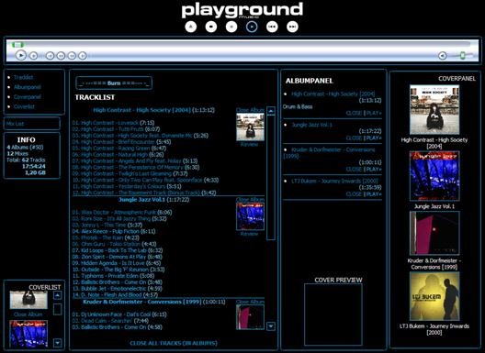
Album & Mix List

History Of Changes:

----------------------------------------------------------------------------
FIX: page wasn’t working if the mp3 file had the wrong length because it was
corrupted or wrong compiled.
----------------------------------------------------------------------------
CHG: added new script that creates batch file for extracting images from cab
file to workingdir, so that you don't have to do it manually anymore.
CHG: changed script names, please remove old before copying updated scripts.
----------------------------------------------------------------------------
NEW: a popup window shows the review and no longer a new tab or browser-
window.
NEW: name of the review and the cover now can be defined.
CHG: now the cover-popup supports Opera without switching it to Mozilla or
Internet Explorer in the settings.
----------------------------------------------------------------------------
NEW: embedded Windows Media Player (supported only by Internet Explorer 4.0
and up)
CHG: one click plays song in embedded media player, double click opens song.
CHG: all necessary tag information's are stored in the array, what reduce
file size & speed up export time.
CHG: faster displaying albums in tracklist via albumpanel.
CHG: css is replaced from "Music Playground Files" folder to head of html
page.
CHG: review is open in popup win.
FIX: better support for Opera & Mozilla Firefox.
FIX: some minor bug fixes.
----------------------------------------------------------------------------
FIX: little bug in css.
----------------------------------------------------------------------------
CHG: colors in style from orange to blue.
CHG: removed zero if it is first digit in length.
FIX: it is now possible to use ' (apostrophe) in folderpath or filename and
# (number sign) at beginning of folder or filename.
----------------------------------------------------------------------------
NEW: review link for each album in tracklist.
FIX: playlist is ANSI encoded.
----------------------------------------------------------------------------
NEW: auto-sizing image popup window.
CHG: image link in coverpanel is enqueue album and directory link is enlarge
image.
----------------------------------------------------------------------------
CHG: style.
----------------------------------------------------------------------------
NEW: added total album time in tracklist.
CHG: many changes in style (css and pictures).
FIX: much better support for Opera & Mozilla Firefox.
----------------------------------------------------------------------------
NEW: added enqueue in albumpanel.
NEW: total tracks, time and size in info table.
CHG: albumpanel change albums in tracklist.
CHG: "No mixes available !" message is displayed in mixes table when page is
loaded.
FIX: link & on hover link colors are fixed.
FIX: cover in coverlist with id 210 and more did not work.
FIX: better support for Opera & Mozilla Firefox.
----------------------------------------------------------------------------

